**ASSIGNMENTS ON DIGITAL MARKETING**

**NAME:** SASIKUMAR.V

**DEPARTMENT:** BE BIOMEDICAL ENGINEERING

**COLLEGE:** 8151 DHANALAKSHMI SRINIVASAN INSTITUTE OF

TECHNOLOGY

**NAAN MUDHALVAN COURSE**: DIGITAL MARKETING

**NM ID:**7170ED4CB8D50D88079443B12D47FA8B

**ASSIGNMENT 1:**

Create a blog or website using Blogspot and WordPress. Customize

The theme design and post new article with 500 words.

<https://wordpress.com/pages/gogreenorganics6.wordpress.com>

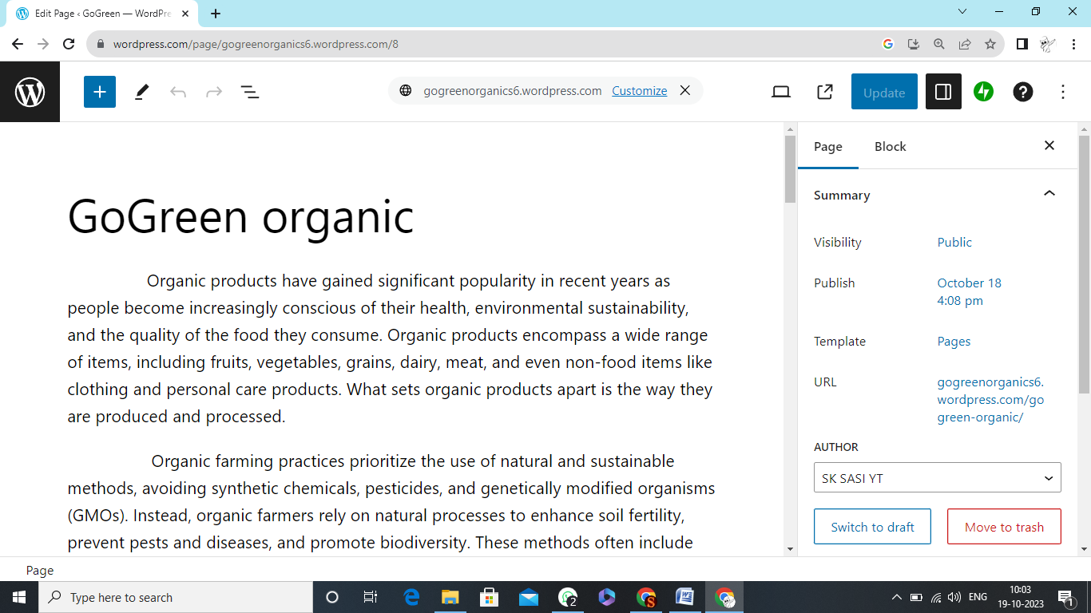

**ASSIGNMENT 2:**

Create a new Facebook business Page and Post one social media poster for your brand.

<https://www.facebook.com/profile.php?id=61550278423372&mibextid=ZbWKwL>

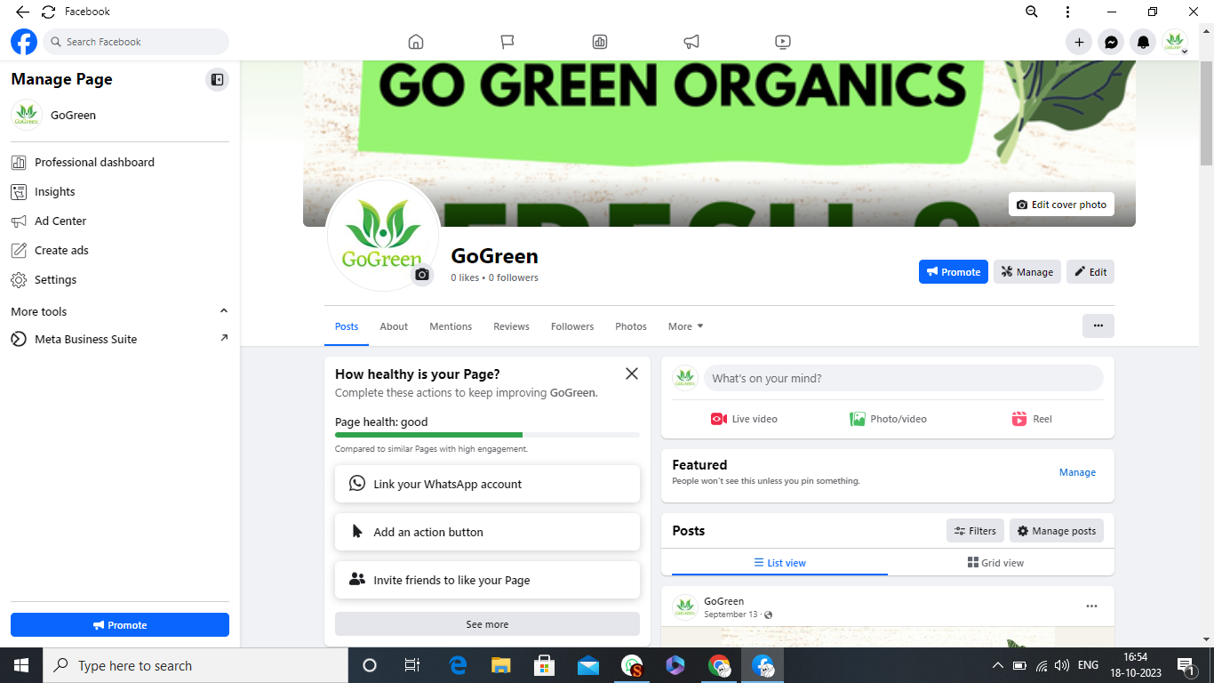

**ASSIGNMENT 3:**

Create and design a social media advertisement poster using Canva.

<https://www.canva.com/design/DAFuTl9gQT4/4p5YREmHIpNK2PSRWQ8N5A/edit?utm_content=DAFuTl9gQT4&utm_campaign=designshare&utm_medium=link2&utm_source=sharebutton>



**ASSIGNMENT** 4.Create email newsletter design usingMailChimp or Canva tool

<https://gogreen1611.blogspot.com/2023/10/e-mail-newsletter-design.html>

